German Financial Cooperation with the „Western Balkan Six Chamber Investment Forum” (WB6-CIF)

Regional Challenge Fund Project

Procurement of medical equipment, hotel equipment, IT equipment, software and furniture of adapted classrooms for "Kristo Isak" Vocational School

Europe (non-EU), Republic of Albania (ALB)
Reference number: RCF/ALB/G/2023/011

The answers to requests for clarifications received by the potential bidders to the following e-mail address: procurement@rcf-wb6.org

Q1 | Lot 2 - Procurement of HoReCa equipment  Item 1 – Professional drying machine. We have contacted our supplier and he explains to us that the item according to the requested specifications, specifically "Without exhaust or water cooling system", can be offered but has a very high initial cost and also in maintenance.  For the specific case, we recommend a normal dryer with a much more economical price.
A1 | Technical specifications were revised. Please refer to document (MS Excel file): 3 - ALB 075 - Technical Specifications - Corrigendum_11062024, LOT 2, Item 1.  Tumble dryer designed for commercial use, suitable for handling laundry loads of 12kg or more and suitable for laundromats or hotels.  Loading capacity: 12 kg or more  Drying type: Vented / Condenser  Drum volume: 200 liters or more  Drum material: Stainless steel  Reversing drum.  Heating option: Electric  Control system: Microprocessor-based / Programmable  Drying time: Approximately 60 minutes (for cotton materials)  With drying programs and timed drying, such as for cottons, synthetics, mixed loads etc.  Front double glass door  With LCD/LED display and control panel.  Preferred with Emergency stop option, Overheat protection, Door lock during operation.  Preferred energy efficiency class A+ or better.  Warranty at least 5 years (for the motor drum).  Installation is included in price.  User instructions manual in at least English language.
Q2 | Lot 2 - Procurement of HoReCa equipment  Item 4 - Restaurant Chafing equipment dishes set. We need a photo for this product and dimensions if possible. Is this item a set of 2 chafing (180 and 90 degrees) and a shelf?
A2 | Technical specifications were revised. Please refer to document (MS Excel file): 3 - ALB 075 - Technical Specifications - Corrigendum_11062024, LOT 2, Item 4.  Indicative examples (lookalikes) provided below:  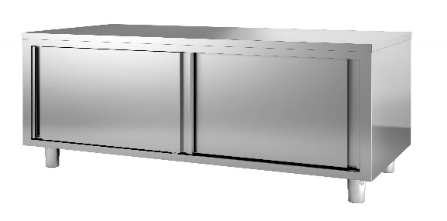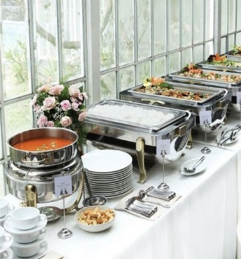  Set of chafing dishes (fulfilling complete set such as, container, frame, heater, etc)  2 x Chafing dish GN1/1, Roll-top cover  Stainless steel material  Roll top cover opening 90 to 180⁰C,  GN 1/1 tray  With 2 ELECTRIC heaters included  Approximate dimensions: LxWxH 70cmx50x40  Volume: 8-10 liters  2 x Chafing dish GN1/1, Roll-top cover  Stainless steel material  Roll top cover opening 90 to 180⁰C,  GN 1/1 tray  With 2 GAS heaters included  Approximate dimensions: LxWxH 70cmx50x40  Volume: 8-10 liters  3 x Chafing dish, Roll-top cover, Round shape  With electric heater included  Stainless steel material  Roll top cover opening 90 to 180⁰C,  Volume: 5.5 liters to 7 liters  1 x Soup chafing dish  Stainless structure and lid  With electric heater (and structure) included  Volume: 7 litres or more  1x Stainless steel table (counter look), bottom enclosed shelves with sliding doors.  Approximate dimensions: L200cm x W75cm x H90cm  Without backsplash  Preferred inside with movable shelves/divisions for placing dishes.
Q3 | Lot 3 – Procurement of furniture (for bar, restaurant, hotel and class adaptation)  Item 2 – Shelves – Can we have an illustration or a photo of the shelf?
A3 | Technical specifications were revised. Please refer to document (MS Excel file): 3 - ALB 075 - Technical Specifications - Corrigendum_11062024, LOT 3, Item 2.  Indicative example(s) provided below:  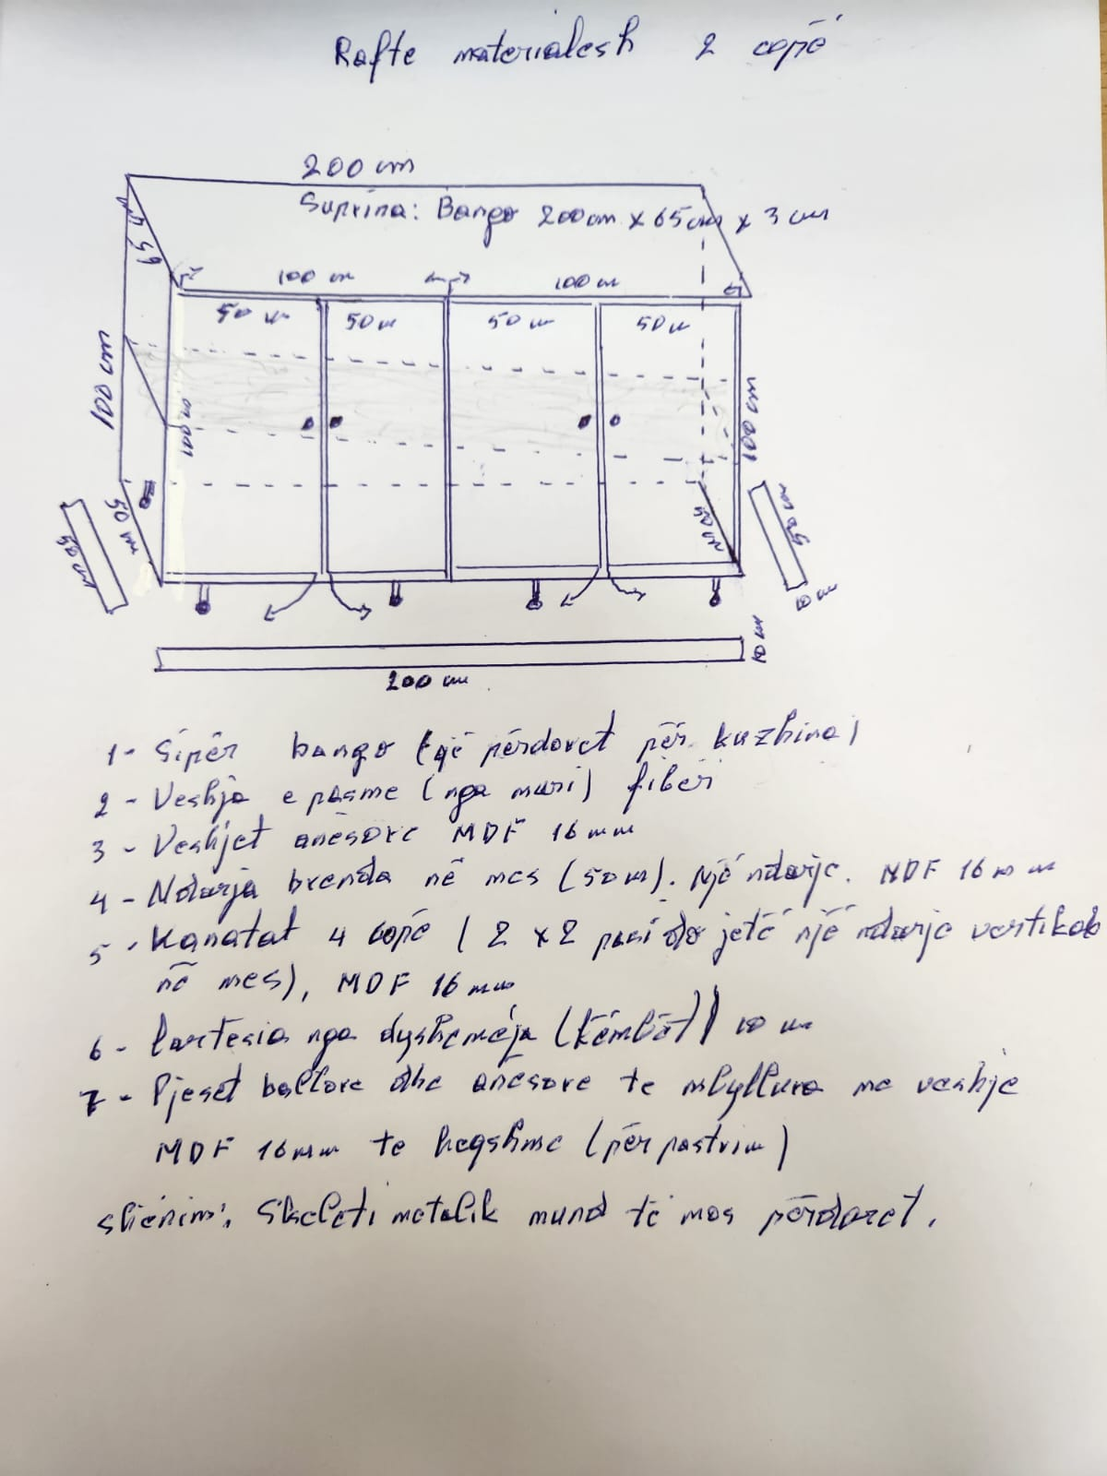  Shelve/cabinet,  Approximate dimensions: L: 200cm, W: 50cm, H:100cm  Top: bango 25 mm  The lower part (front and side and bottom) closed with four folds (2 x 2), in two partitions about 800 x 45 x 18 mm, MDF material 18 mm.  Inside with a movable shelf for each compartment.  Empty space from the floor 10 cm  Optional: Metal frame, profile 3 x 2 cm or 2 x 2 cm.
Q4 | Lot 3 - Procurement of furniture (for bar, restaurant, hotel and class adaptation)  Item 24 – Chairs for students (Furniture for Health care room/cabinet) - The specifications do not require wheels, while in the photo of Annex no. 4, the model of the chair is with wheels. Also, should the structure be stainless steel or other metal?
A4 | Technical specifications were revised. Please refer to document (MS Excel file): 3 - ALB 075 - Technical Specifications - Corrigendum_11062024, LOT 3, Item 24.  Indicative example(s) provided below:  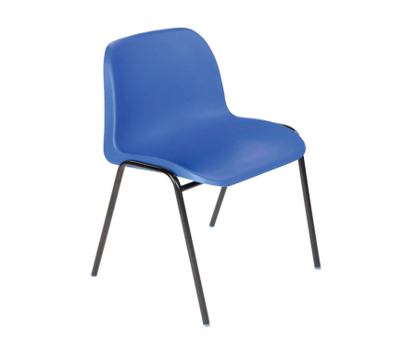  Chairs for students  Preferred color: Blue  Material Plastic with stainless steel legs.  Preferred dimensions: Seat height 50 cm and support 50 cm
Q5 | Lot 3 – Procurement of furniture (for bar, restaurant, hotel and class adaptation)  Item 38 – Chairs for students (Furniture for Social care training room/cabinet). Can we have a photo for this item because we are confused by the fact that the chair has a wooden top and metal legs. The chair can be either wooden or metal.
A5 | Technical specifications were revised. Please refer to document (MS Excel file): 3 - ALB 075 - Technical Specifications - Corrigendum_11062024, LOT 3, Item 38.  Indicative example(s) provided below:  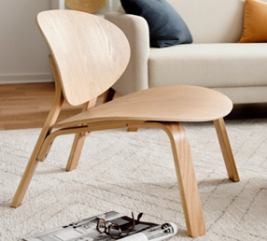  Chairs for children  Material: Wood  Color: light brown wood color  Dimensions: Seat height 35 cm and support 30 cm
Q6 | Lot 3 – Procurement of furniture (for bar, restaurant, hotel and class adaptation)  Also, if you have photos or sketches of furniture items, please send them to us.
A6 | Please refer to document (MS Excel file): 2-1-8 Furniture for the section Construction and Building Corrigendum, under MS Excel line 36.  IMPORTANT NOTE:  All photos presented within the Technical Specifications are INDICAVTIVE only. Any references towards brand names/color names/pictures of equipment are mentioned with the sole purpose to serve as an indication of the technical features to be complied with by the tenderer.

